ISSACK WAITHAKA
cs-sa07-24085

WiFi Hacking 101
- SSID – name of the network
- ESSID – multiple access points or network you are trying to attack
- BSSID – access point mac address
- WPA2-PSK – wifi that you connected using password
- WPA-EAP – wifi that you authenticate using username and password
- RADIUS – A server with authenticating clients

Questions
1.
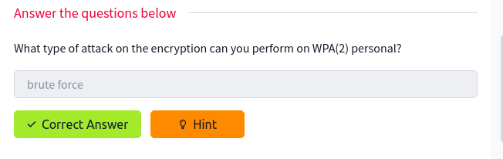
2.
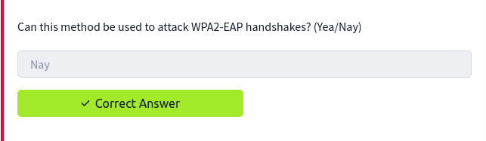
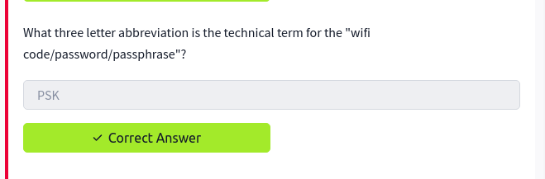
3.

4.

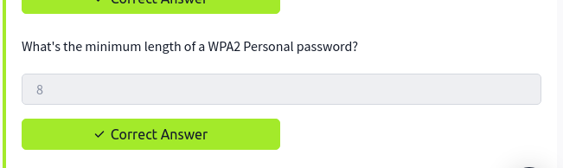

You are being watched
- Aircrack-ng suite is a tool that is used to attack a wifi network
- Well use aircrack-ng, airodump-ng, airmon-ng to attack WPA networks

Questions
1.
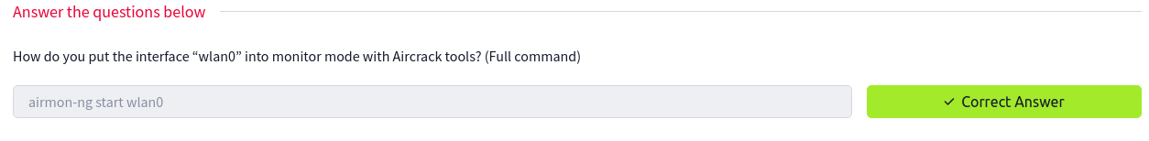
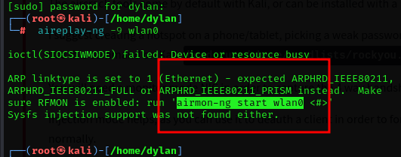

2.

3.
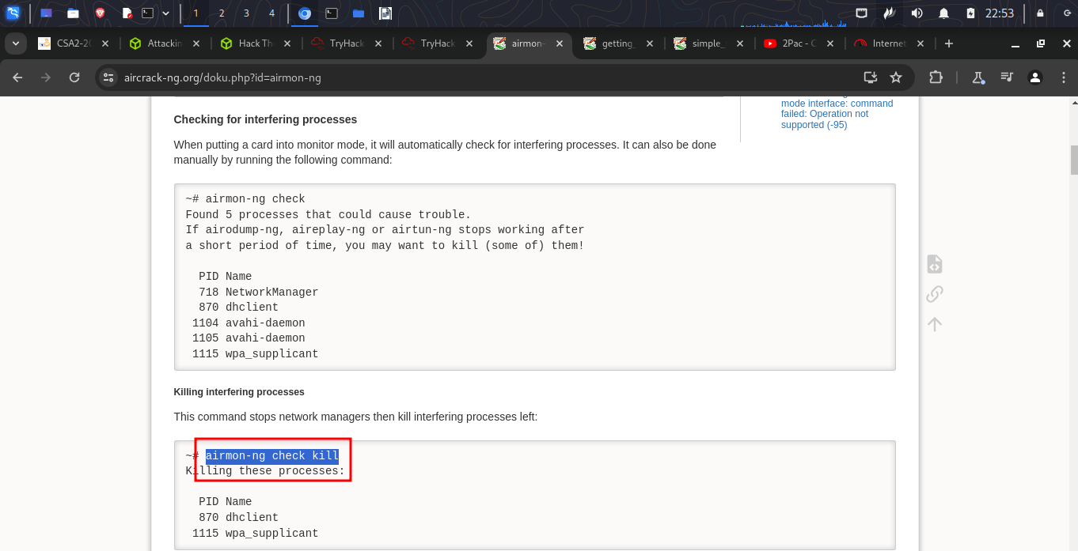

4.
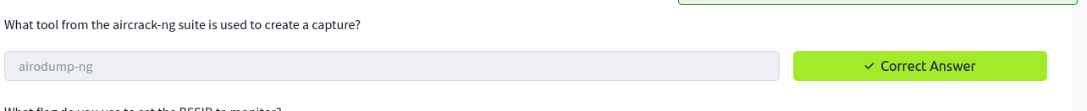
5.
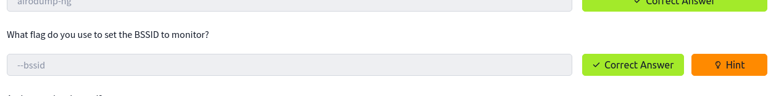
6.
7.
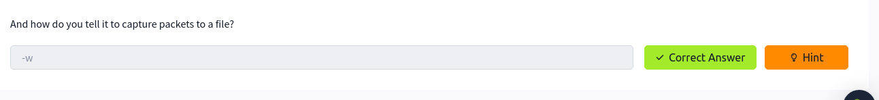

Aircrack-ng lets get cracking
- In this room we are given files to download and work on

Questions
1,2
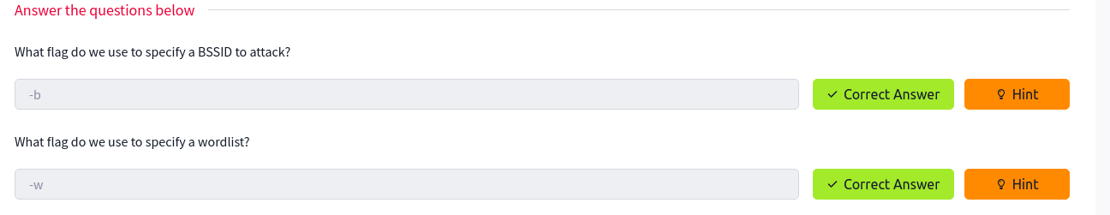
3.
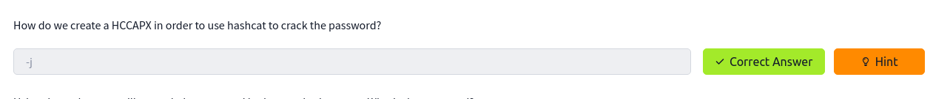

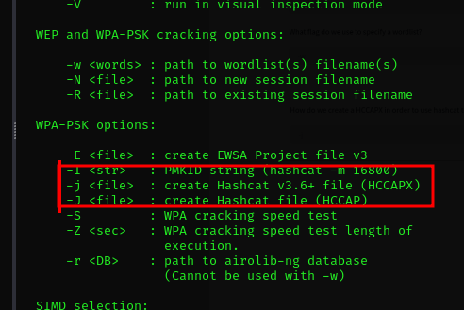

4.

I used the following command to crack the capture file
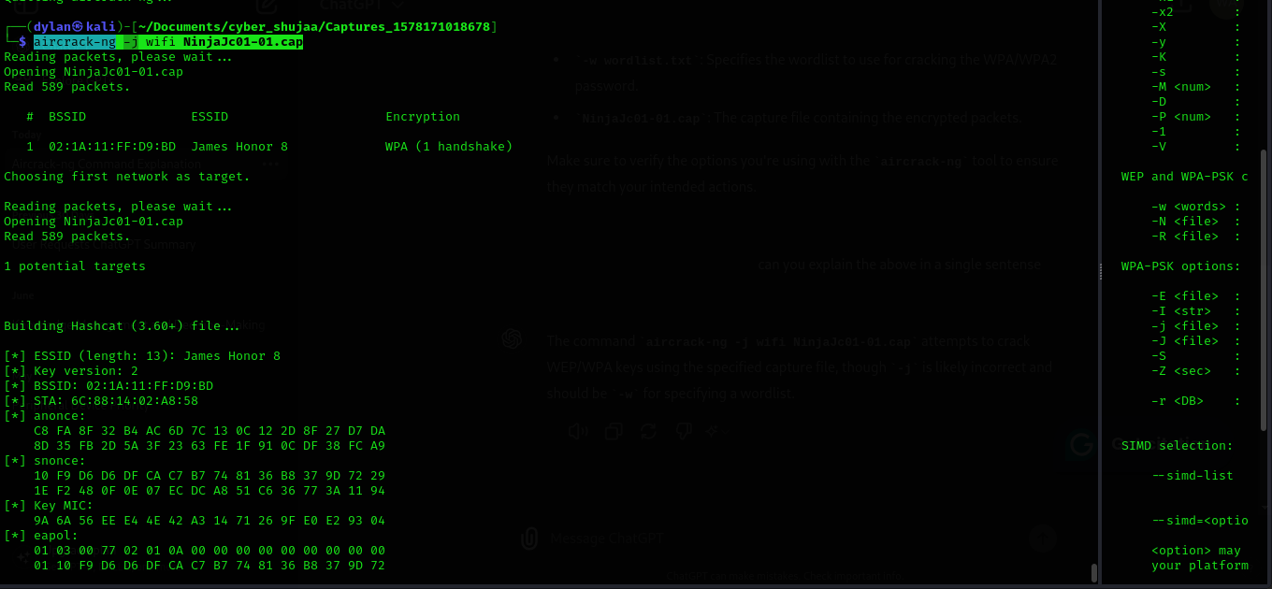
and got the following file
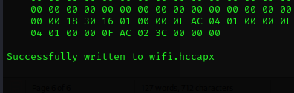

I then tried to crack the file to find the password
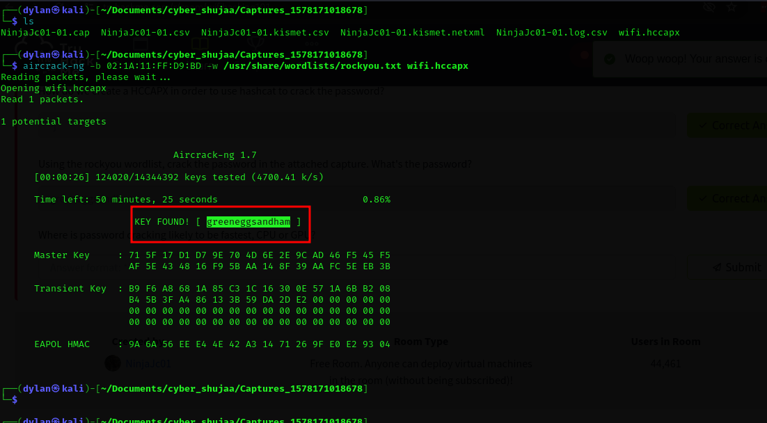

5.
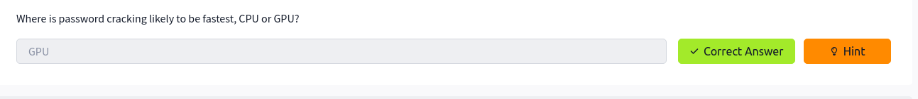
The answer is GPU because it can handle many calculations simultaneously.

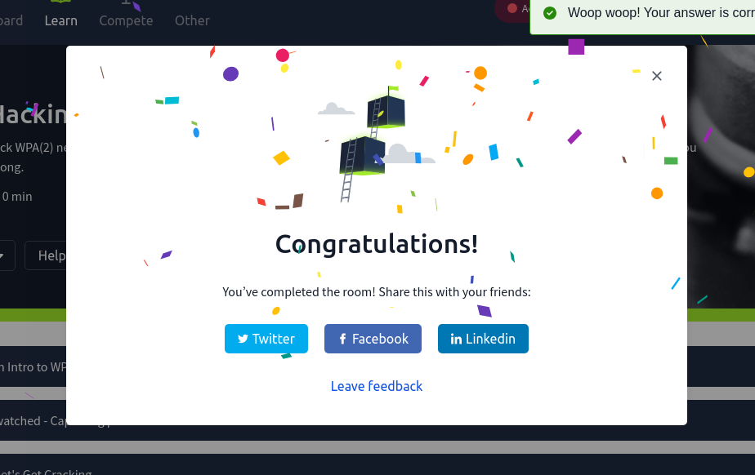
Conclusion
In this room I have leant the different terms used in wireless networks. I have also gone through some of the tools that can be used in wifi hacking. It was a very interesting room and I enjoyed it very much.

